Join the Fun!  Golf with other amputees at our Annual Adaptive Open held in September each year at the Odyssey Golf Foundation in Tinley Park IL!  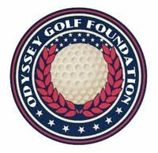  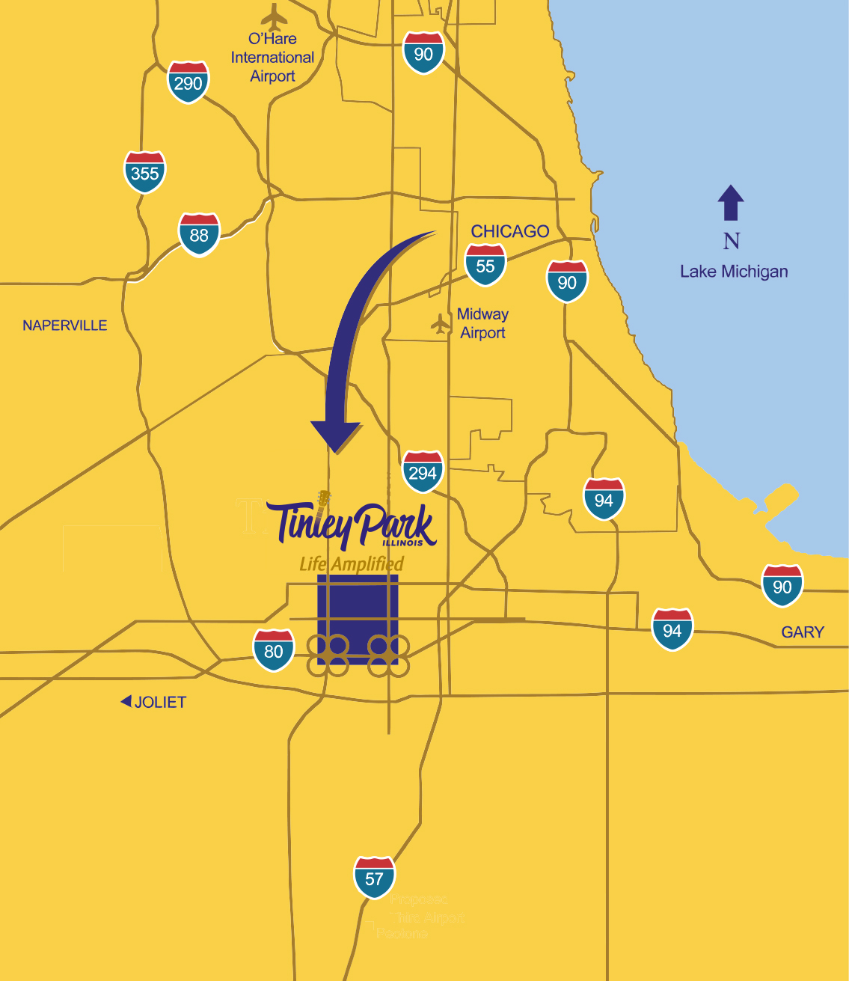 |  |  | midwestern amputee golf association  PO Box 1354  Northbrook, IL 60065-1354  Bradley Schubert  (847) 652-0011  mwaga.info@gmail.com  facebook.com/amputeegolf  mwaga.org |  |  | _{RiesenPhotography.com}  midwestern amputee golf association  - Our Mission: Is to utilize the game of golf to promote friendship, fitness, fun and rehabilitation for individuals with physical limitations.

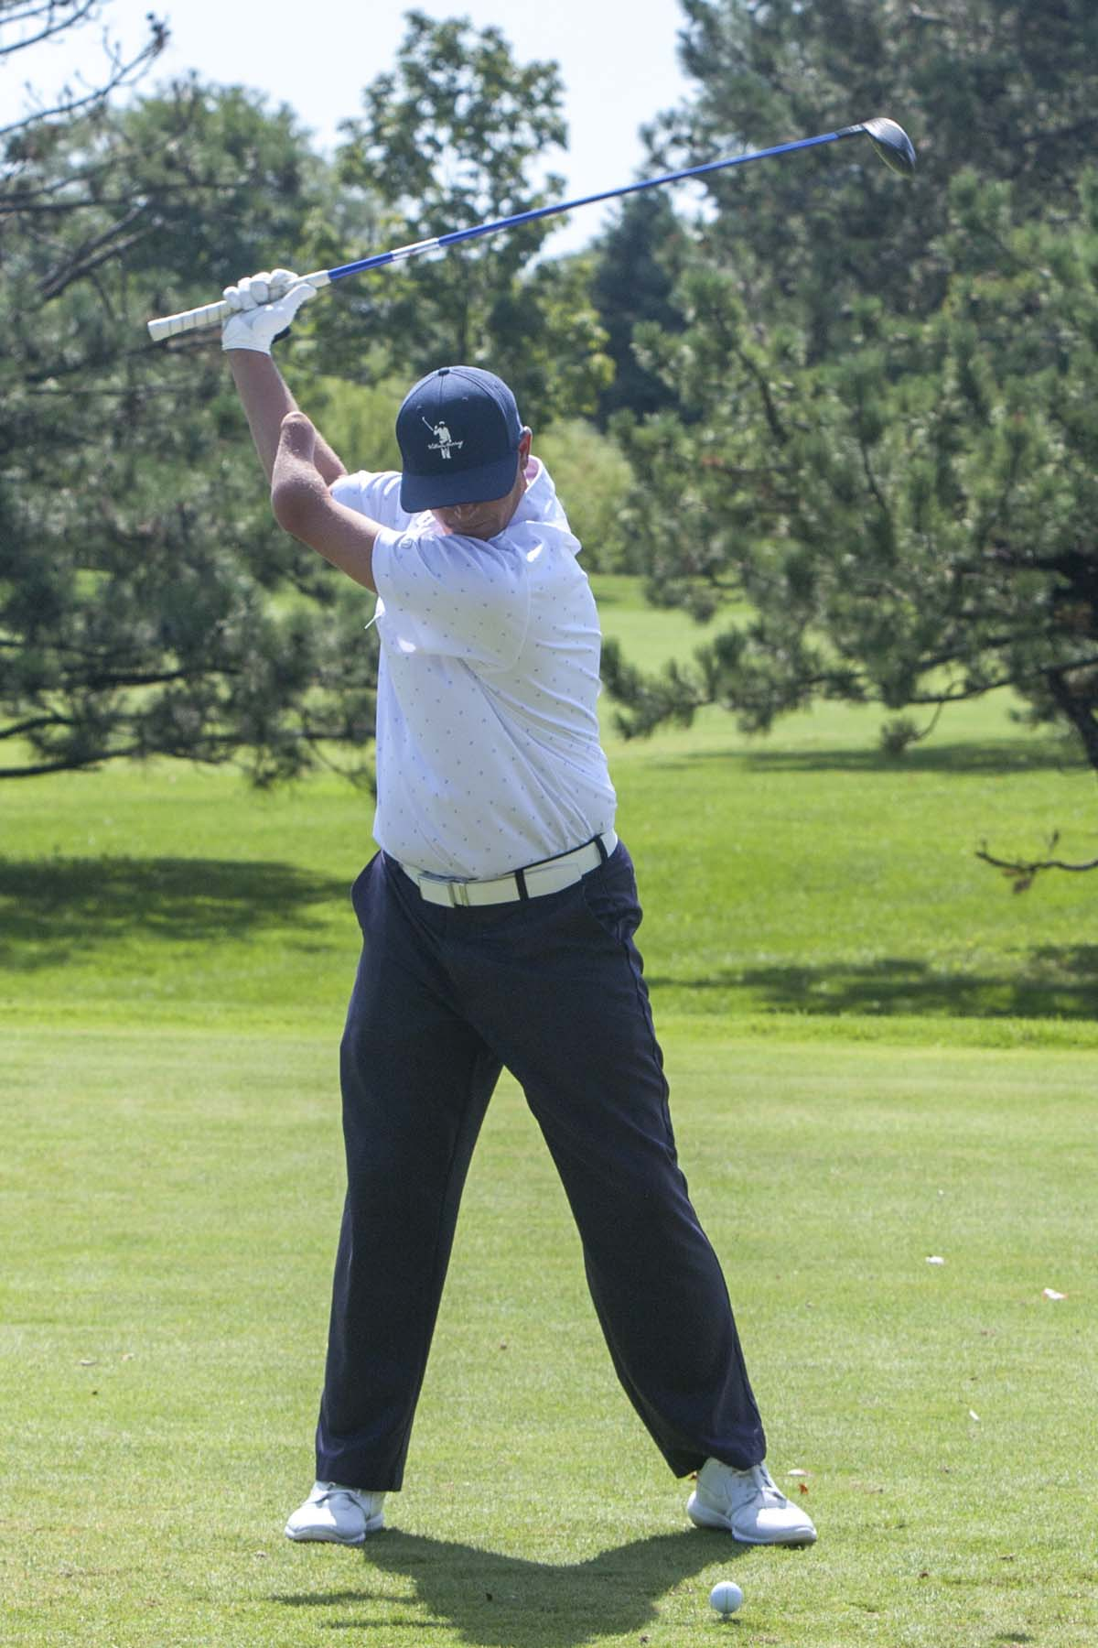 RiesenPhotography.com  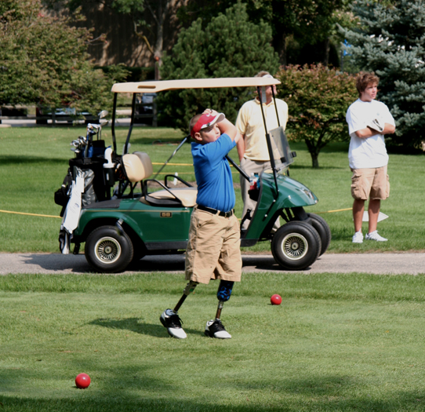  Our Mission:  Is to utilize the game of golf to promote friendship, fitness, fun and rehabilitation for individuals with physical limitations. |  |  | MWAGA Adaptive Open and Scramble Weekend  Each year, we host our Annual Adaptive Open and Fundraising Scramble traditionally on the weekend after Labor Day at the Odyssey Golf Course in Tinley Park IL. The Friday Scramble is open to all golfers. During the weekend, we host our Annual Adaptive Open, a 36-hole tournament open to adaptive golfers of all skill levels are encouraged to participate during the weekend.  Our Adaptive Open is for all players with physical disabilities and all skill levels and awards all skill levels. For more information and registration, visit our website at MWAGA.org  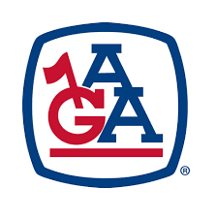  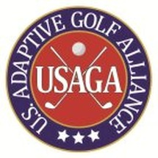  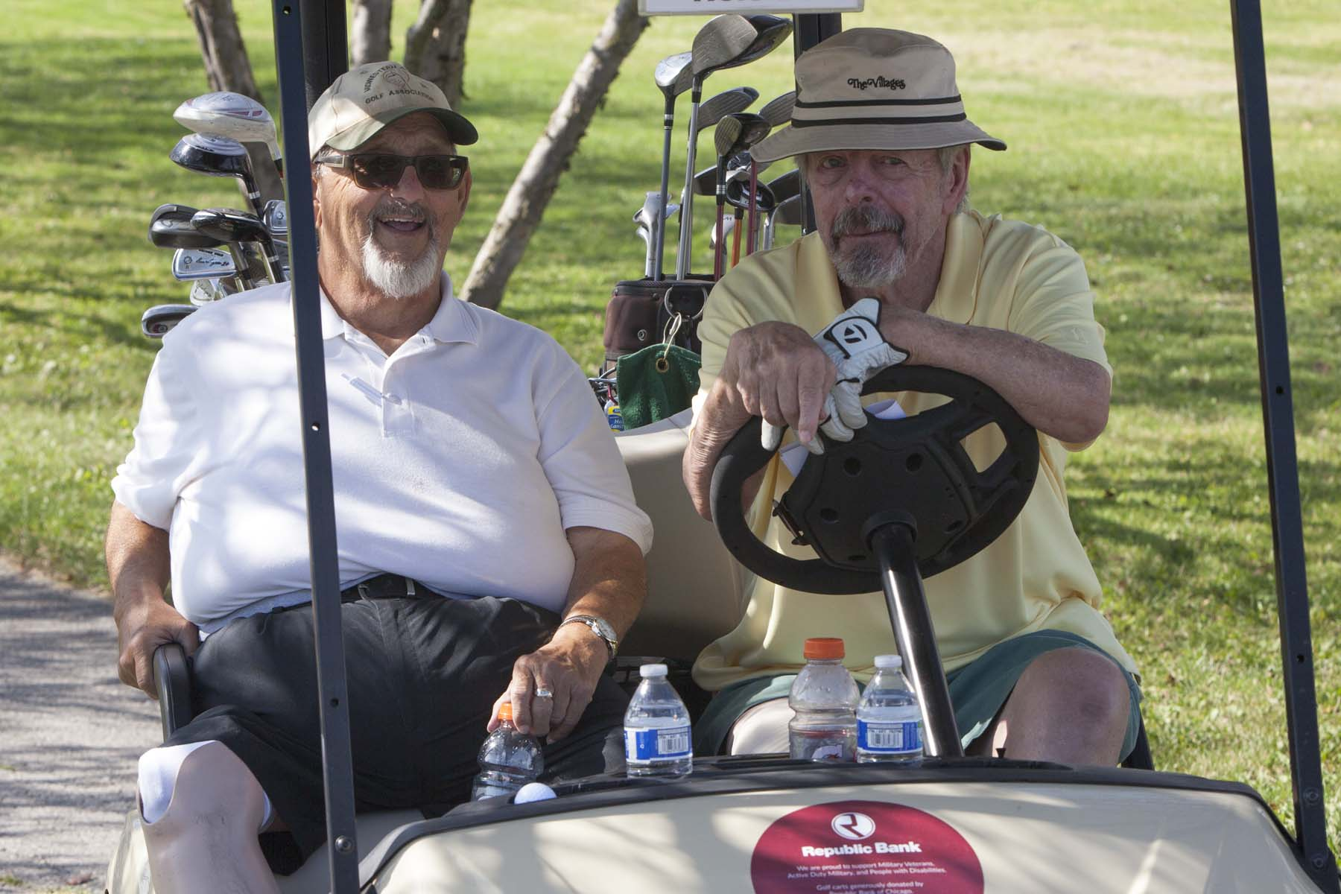 |  |  | 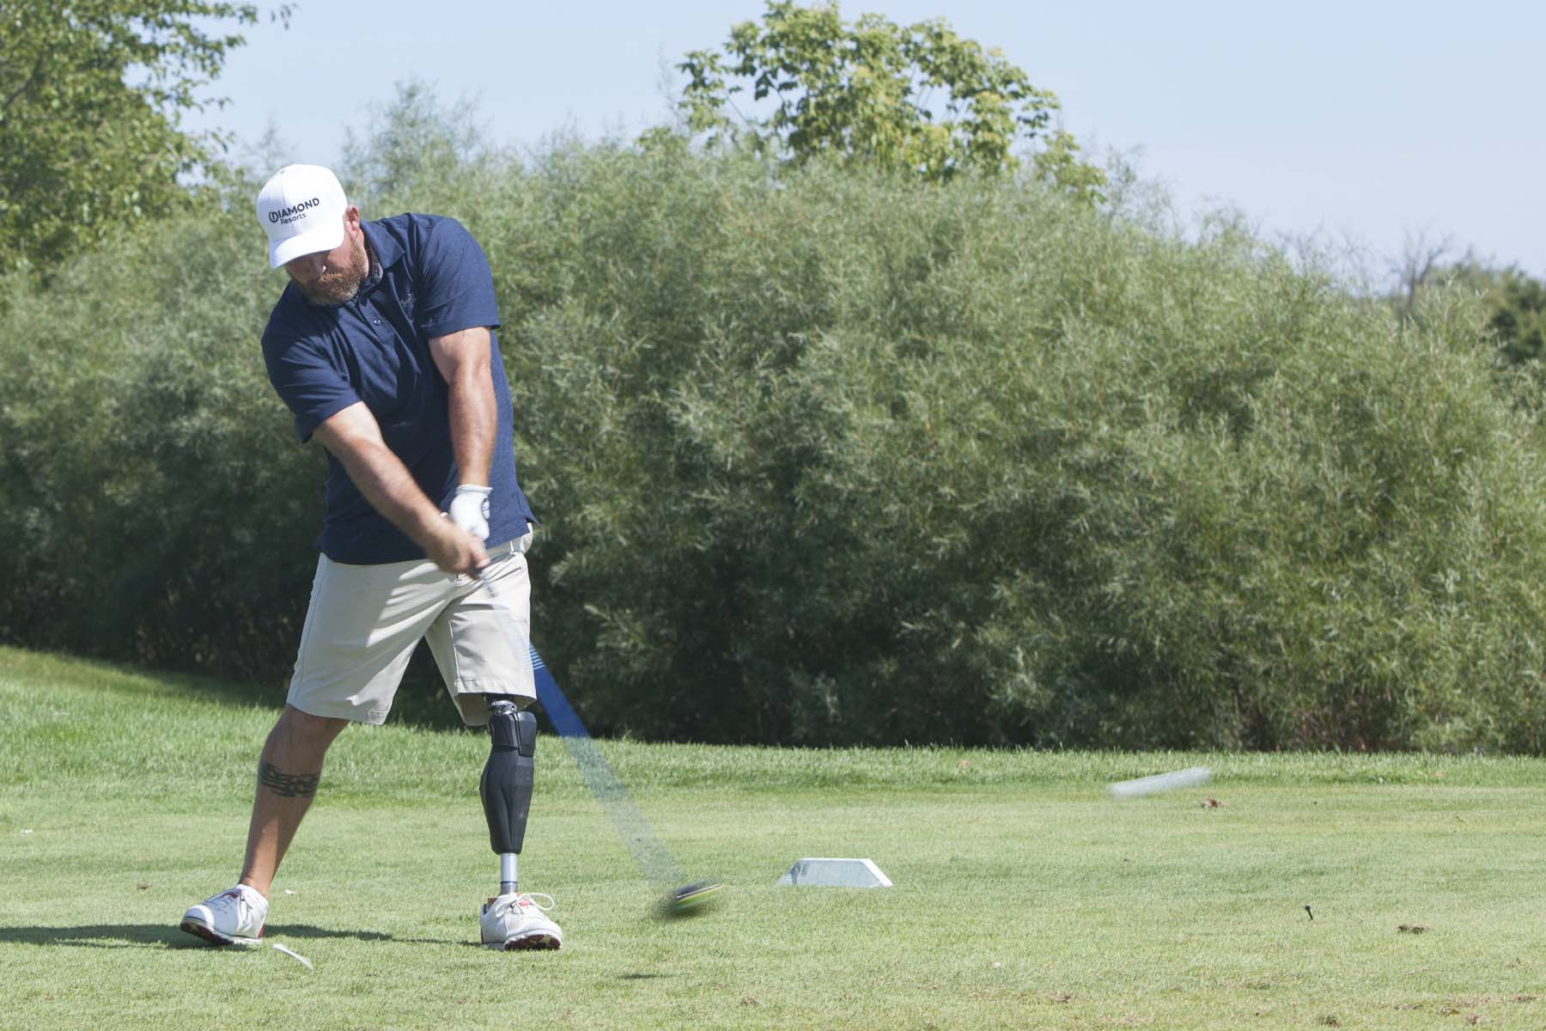 RiesenPhotography.com  Who We Are…  Established in 2001, the Midwestern Amputee Golf Association (MWAGA) is a volunteer group of individuals who have experienced and overcome the loss of a limb or limbs and utilize the game of golf to promote friendship, fitness, fun and rehabilitation through active participation in golf for amputees of all ages.  MWAGA is headquartered in Northbrook, IL and includes Illinois, Ohio, Michigan, Indiana, Wisconsin, Iowa, North Dakota, South Dakota and Minnesota in its region.  Our association is under the larger umbrella of the National Amputee Golf Association (NAGA: www.nagagolf.org) headquartered in Smyrna, TN.  We do more than play golf…we provide yearly academic scholarships to amputees & family members of amputees, we conduct “First Swing” golf clinics for disabled golfers.

